**PROJECT DEVELOPMENT PHASE**

**SPRINT-1**

|  |  |
| --- | --- |
| Date | 12 November 2022 |
| Team ID | PNT2022TMID00923 |
| Project Name | Signs with Smart Connectivity for Better Road Safety |

**SPRINT-1:**

* In sprint-1, we collect temperature and humidity data from OpenWeatherMap website for a particular city as input.
* We have developed the code for the same and to publish it to IBM IoT Watson, node-red and finally display them in MIT APP INVENTOR.
* We have also implemented a condition such that, if humidity is less than 100, then it displays a warning like “PLEASE SLOW DOWN”.

**PYTHON CODE:**

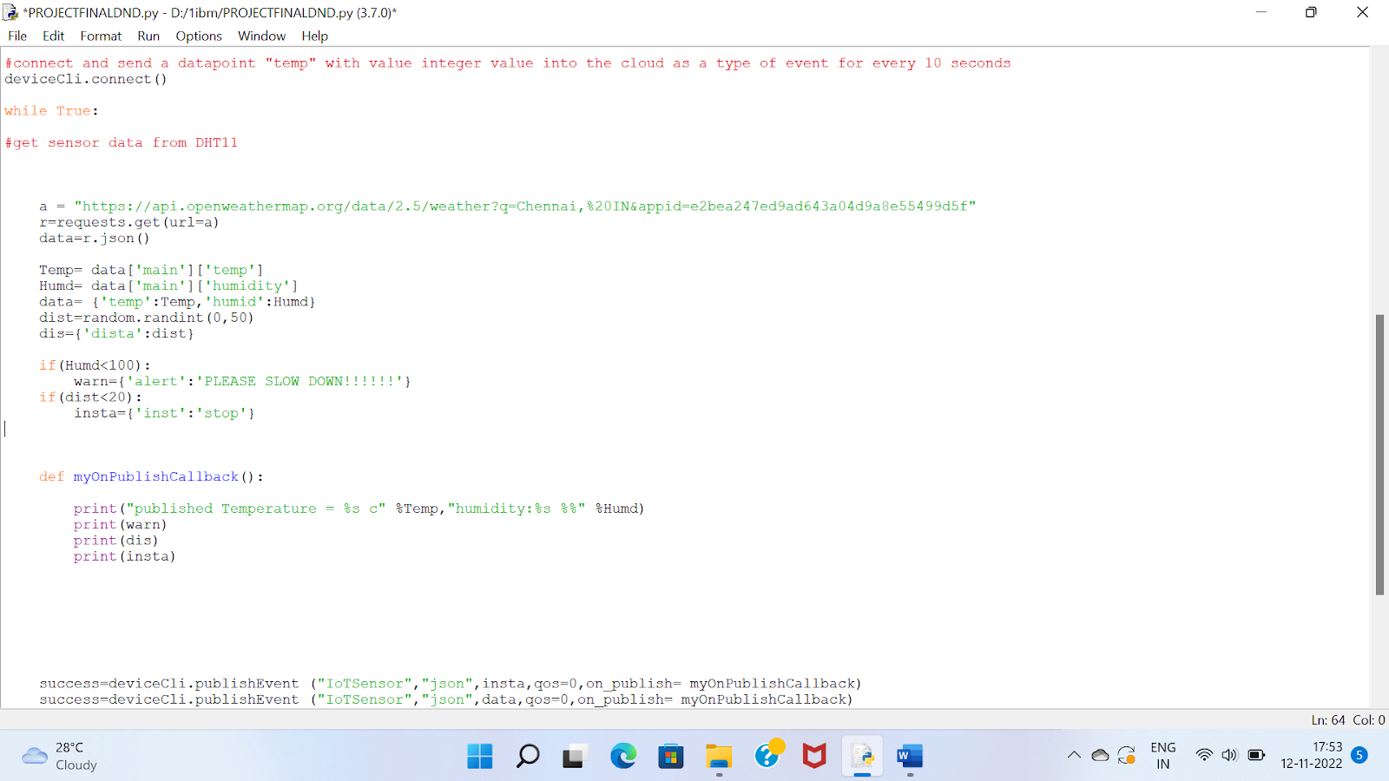

**IBM IoT WATSON PLATFORM:**

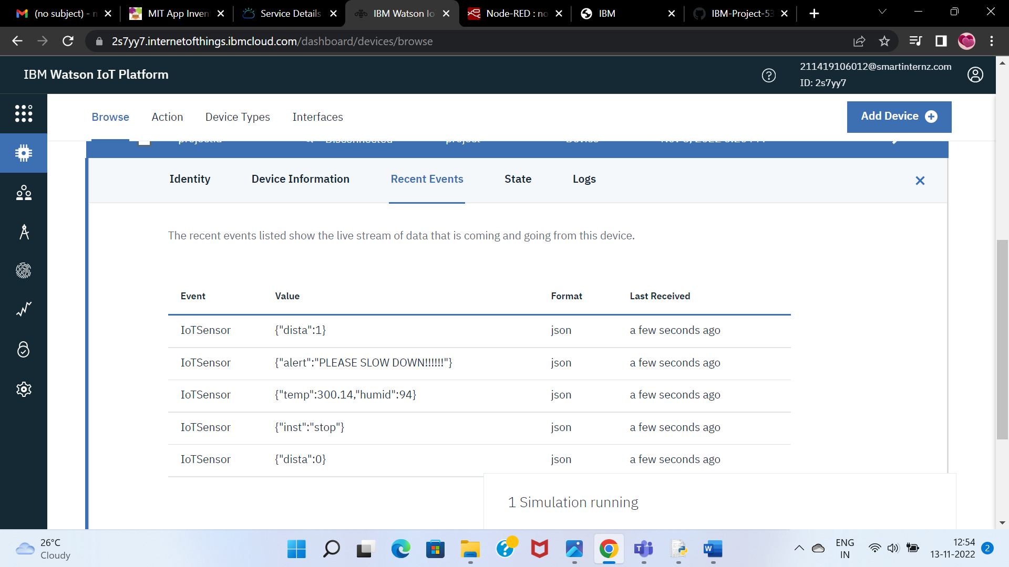

**NODE-RED:**

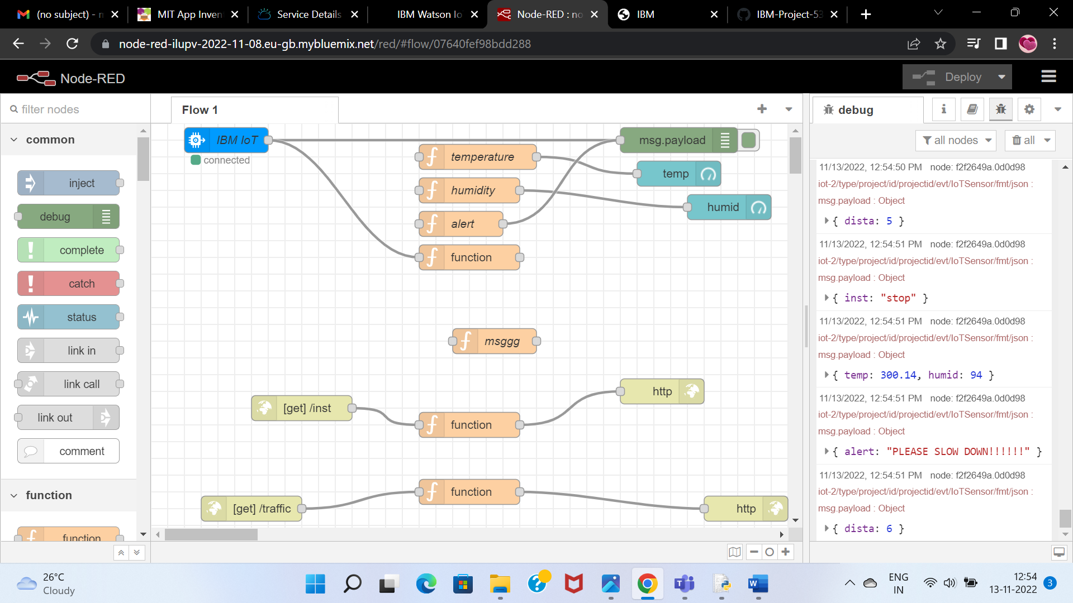

**MIT APP INVENTOR:**

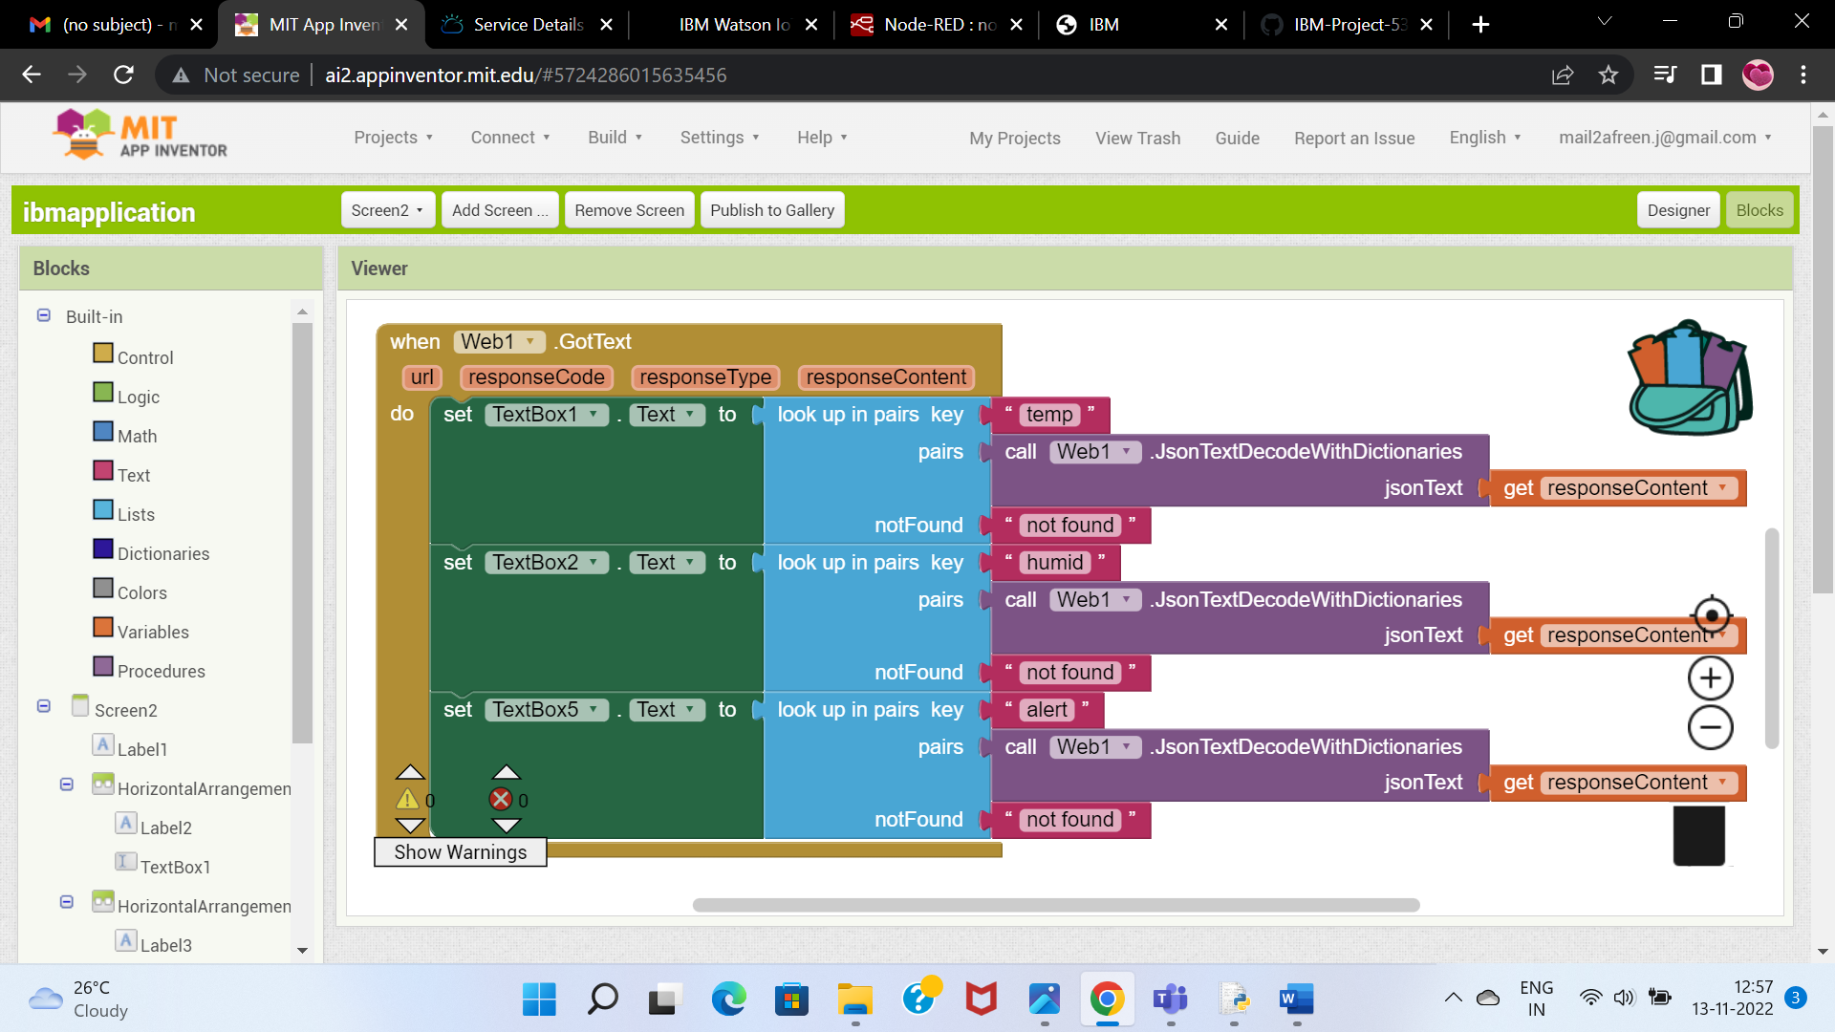

**USER APP SCREENSHOT:**

